**Chapter 1**

**INTRODUCTION**

“Online” is a today’s “Buzzword” which every organization is looking for their representation globally. The revolution’s in internet technology and web application has a great impact on various fields especially in information processing field. A person can get the information about anything instantly just by a mouse click which saves the precious thing called time as well as money.

The internet began in 1969, as an experimental four computer network called “Arpanet”, which was designed by the US defense department so that research scientist could communicate. In approximately 2 years “Arpanet” grew to about 2 dozen sides and by 1981, consisted of more than 200 sites. In 1990,”Arpanet” was officially disbanded and the network, which now consists of 1000’s of sites came to known as “Internet”.

The internet consists of 2 types of computers servers & Clients, computers which offer information to read are called servers computers that read the information offered are called clients. Servers run special software’s (Web server software) that allows them to respond to client requests for information, accept data from clients. Some of the most popular software which serves run to allow them to respond to client requests for information is internet information server (IIS), Apache web server, Microsoft Personal web server.

**1.1 About the project**

Our project entitled “Intranet Search Engine For Academic Projects” is an intranet web application product designed to manage the details of students’ academic projects carried out in our college

This project is mainly designed to manage the project details carried out by the students of various academic years.

Here the details of projects are presented according to the technology used, academic year and according to guide also.

An easy to use interface has been developed using HTML and java script, the database has been managed using MySQL, Apache web server has been used and server side scripting is done using JSP. Here students could make use of this application by searching the projects according to technology used , academic years, project mates name, guide name etc

Guides could login with their username and password they could edit the details of projects which are being guided by them. Admin has more privileges on data base.

**Key features**

* To develop a web application software to maintain and manage the details of

Projects developed by students

* To achieve accuracy in managing the records
* To develop an intranet search engine for searching the project details by the students for various conditions.
* To increase the speed of operation
* To reduce the conventional resources used to manage the data.
* To develop a reliable product

**1.2 Company Profile**

Situated in the IT capital of India, Bangalore, we are a multi-brand programming advancement and spread association obliging affiliations and end customers. Our extraordinary perception of end customer necessities and the business needs help with helping our customers in settling on the right choice when they purchase programming. Allow it to be a fundamental piece of programming that you have to purchase to make your customary enlisting less requesting or let it be a complex and imperative programming pack you have to purchase for your affiliation, we are here to give you the assistance with settling on the right choice. Cimphysoft looks for pride in the customer advantage that we have been giving them We don't stop by essentially offering you the item; nonetheless, we will walk that extra mile with you in setting it up.

Home and Personal Use Software

We create Microsoft working framework perfect items that will help you in making your regular registering much progressively fun. We likewise give different PC security basics to keep your PC and information secure. We trust in giving you the most ideal help. We will help you in settling on the right choice in programming, working structure and security programming. We will walk that extra mile in helping you in presenting the item as well.

Business and Enterprise Software

We at Cimphysoft comprehend the genuine estimation of productivity of your workforce. We have a wide scope of programming items to improve profitability and proficiency of your organizations. As a market chief in programming advancement and circulation, we have intently worked with a portion of the effective business existing today and we have helped them in settling on the correct decision with regards to the product that they keep running on their business machines. We give you an unmatched administration and a top notch cost. We offer different Resource Planning programming, Productivity programming and Business arranging programming.

Ace Design Software

Is it accurate to say that you are an architect working in Graphic, Web or Engineering structure spaces? we have the correct arrangement of devices to help you in your calling. We likewise manage instructive licenses for schools and universities that require these apparatuses to prepare their understudies. As approved affiliates, we disseminate all Adobe items, Autodesk items and Corel items. Find beneath a portion of the product we sell. We give you the most ideal cost on all the product items

Hostile to Virus and Security Software

In this day and age all our business and individual connections spin around information exchange through web. Web is in reality loaded up with sudden risks. To step web cautiously and safe, your PC needs suitable insurance to shield itself and your significant information against all risks. Hostile to Virus and other Network security programming's are basic all programming's your information safe and guarantee no vacation. As approved affiliates, we offer a wide scope of Anti-infection and Security items for individual and business PCs. We likewise give volume authorizing alternatives on these items for organizations.

**Chapter 2**

**LITERATURE SURVEY**

**2.1 Existing System**

In the existing system there is no any software package to manage the project details the details of project developed are stored by means of files manually. It is the responsibility of the guide to maintain the details of projects developed by the students

**2.2 Limitations of existing system**

* More man power.
* Time consuming.
* Consumes large volume of paper work.
* Needs manual calculations.
* No direct role for the higher officials.
* Damage of machines due to lack of attention

**2.3 Proposed System**

The aim of proposed system is to develop a system of improved facilities. The proposed system can overcome all the limitations of the existing system. The system provides proper security and reduces the manual work. The existing system has several disadvantages and many more difficulties to work well. The proposed system tries to eliminate or reduce these difficulties up to some extent. The proposed system will help the user to reduce the workload and mental conflict. The proposed system helps the user to work user friendly and he can easily do his jobs without time lagging

**2.4 Advantages of proposed system**

The system is very simple in design and to implement. The system requires very low system resources and the system will work in almost all configurations. It has got following features

* Ensure data accuracy’s.
* Proper control of the higher officials.
* Reduce the damages of the machines.
* Minimize manual data entry.
* Minimum time needed for the various processing.
* Greater efficiency.
* Better service.
* User friendliness and interactive.

**2.5 Feasibility Study**

The feasibility study is an evaluation and the analysis of the potential of a proposed system project which is based on the investigation and research to support the process of decision making.

For all new system, the process starts with a feasibility study. The input to feasibility study is the outline description of this system and how it will be used with in the organization. The result of this feasibility study is the report which recommends it is carrying on with project or not.

**Operational feasibility**

This is done to see whether operations of proposed system software can be easily understood by the user and that he spends low time in learning to use the product.

The product does not require any special training on usage of the product one could easily understand the functionalities of the system. Simple easy to understand form, menus and GUI tools have been used

**Technical Feasibility**

The technology feasibility to the proposed system could be summarized as below.

*Data storage*

All the project related information is stored in the MYSQL database which is the best suited database for distributed application, it is not required any additional drivers to make transaction’s with this MYSQL database, the proposed system works on the principle of client-server architecture it does not need additional software at client side to make the system functional

*Web server*

Web server provides service to clients by accepting client request and those request will be served by the server and server will examine the requested client request and perform the operation by using Apache tomcat web server which also provide service at 8080 available port, web server has to perform operation to provide service to client instantly, it provides excellent service on Linux platform which provides a multiple user operating system. Web server is a communication between the client and server where client request to server to provide the service requested by client server accept the http request from client and process it and fetch the required information and send back to the client. *Server Scripting*

In the proposed system JSP language used to make server side scripting and JSP language supports object oriented language as well as procedural language and it is compatible language and also it supports various data types and also it supports to for each loop concept which is very useful to provide navigation through arrays of various types.

*Economical Feasibility*

This study is carried out to check the economic impact that the system will have on the organization. Since all tools used in the project are open source need not to invest on software’s, but some amount has to be invested regarding domain registration and server purchasing. Apart from it the product is economical and affordable.

**2.6 Tools and Technologies Used**

**Introduction to Java**

Java is initiated specially for the platform independency. Before the origin of java there were many programming languages but those weren’t platform independent.

Java has some features those are very powerful compare to all programming features. Those features are given below:

* Easy and simple.
* Special importance on data rather than procedure.
* Data is not accessible to external function called hidden concept.
* Allocate the new memory for data and function is easy.
* Java is helpful to execute the multithreading program.
* Java to let has secure execution.
* Java has portable concept which we write in one computer and it can execute anywhere or in different computer.
* In java we use exception handling, String handling, Garbage collection etc.

**Introduction to JSP**

Java Server Page is a server page. By Sun Micro System released this in year 1999.It is technology which helps to programmers to create web pages for application. It is embedded with some language called Hyper Text Markup language and other types language are also use. It is used in the java programming code where the java code must be inside the html tags. Where jsp is a similar structure as like a html but the main difference is in jsp is that script tag.

**Introduction to MySQL**

For developing web based software application RDBMS is used. RDBMS is one of the best MYSQL. It is easy to use RDBMS for large and small business. MYSQL give support to large database i. e 50 million rows or more in a table. The default size limit for a table is 4GB. MYSQL works with large datasets quickly. MYSQL works with languages such as C, C++, and Perl etc.

The MYSQL is used here from www.000webhosting .com website with proper authentication to the database access. The database is stored in PHP MyAdmin blog. The database is accessed with the username and password.

Tables are created using SQL in MYSQL database. The database can be modified only after proper authentication to the database.

**Introduction to HTML**

Here web pages are created by a language known as HTML. This language is used to design the web pages. Here web pages are to be formatted by this HTML language.HTML as set of common tags such as <HTML>, <HEAD>, <BODY>and<INPUT>. In this web page we can also insert particular images by using <IMAGE> tag.

In this web page we can also provide links from one web page to another web page by using (<A>) anchor tag. And also HTML forms are begins with the tag called<FORM> followed by the number of input tags. Here all the tags must close with in close in tags, for example form tag must be close with </FORM> tag. Within in a form input elements could be defined as <INPUT> tag, <TEXTAREA>tag, <SELECT>tag, <OPTION> tags and so on.

**Introduction to JDBC**

JDBC is used for database connectivity; it helps to bridge the connection between java application and database. Here jdbc is very useful when programmer wants to save their records in sql and retrieve the data from the sql this is allows execution from java programming

Some Advantages are there, they are:

* Easy to embedded sql queries in java code.
* Easy to call Jdbc driver.
* Easy to connection with database.

**JavaScript**

The JavaScript programming language is an event driven and translated scripting language that would be utilized to create application that will be use create a web application that can either on server or on the customer. JavaScript can be utilized for validating and verifying client enters before submitting to server. Wrong info is identified promptly and the client has opportunity to right the information.

**CSS**

Cascading Style Sheets (CSS) is a [language](http://en.wikipedia.org/wiki/Style_sheet_language) used for documents formatting and for explaining the look in a markup language.CSS is designed for the separation of document content with document presentation elements such as fonts, layout, and colours. This provides more flexibility, increases the accessing of contents, it decreases the difficulties, and also decreases the repetition in the structural contents. If we change to our website’s CSS style sheet then we can automatically make to every page our website. CSS allows multiple pages to format sharing.

**HTTP**

HTTP is language used to describe how the web pages are sent by the internet. Here the server receives the request from the well-known port number .The default port number is 80.And also it is a good port number. Server can also receive other port number. If server receives other port number then server should include a colon and the port number immediately after the server name.

**NetBeans IDE**

NetBeans is the open source integrated development environment available for free to prepare test, debug and test the java programs. It has user friendly interface and To use the quick help, error parser and other facilities which saves lot of time of the developer and one finds handy the tool

IDE first we have to choose the project type as net beans allows to develop Java web, java application and many more type of projects.

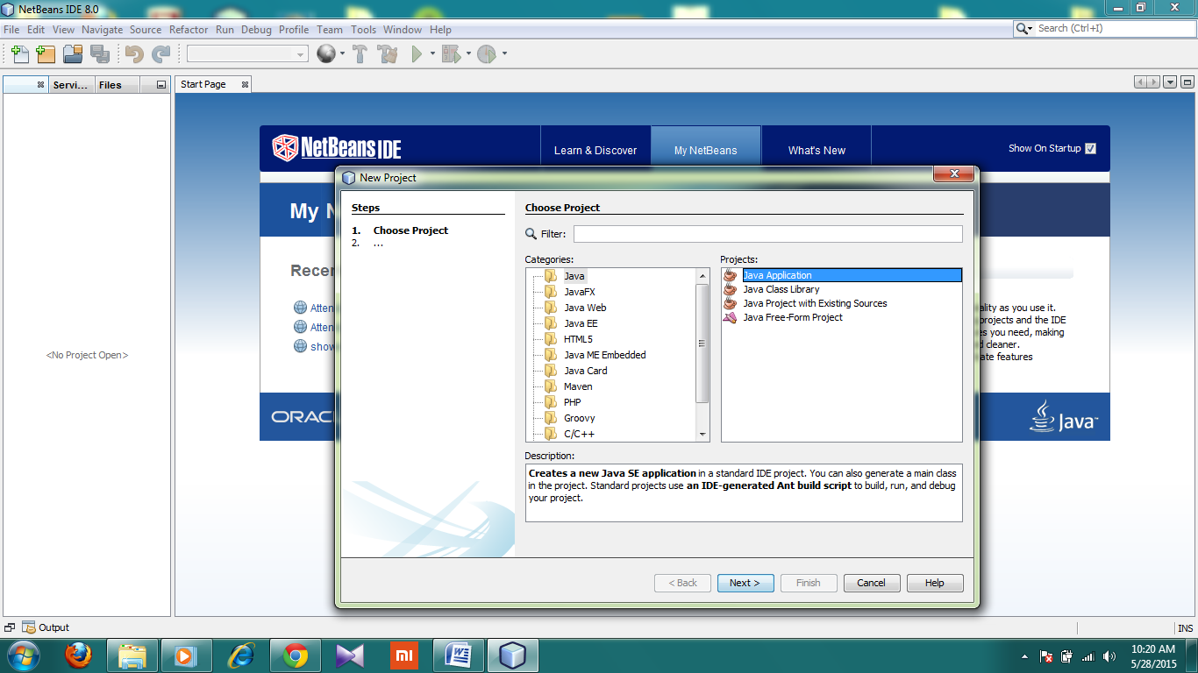

The above snapshot shows the platform of net beans IDE, choosing the project type one could start working and build their applications

The editor provides predefined code structure associated with main() method, user needs to import required packages and start building their code. By clicking run button provided on the top tool bar one could execute the java programs.

**Android**

Android is an open source OS developed for smartphones by the Google. It works on the principle of Linux kernel, it has various layers, for developers there is a layer called application layers at that layer various functionalities are provided.

For developing the android application an IDE called android studio is used, in android studio various files are used for different purposes. Example Activity Is a java file which defines the activity of the app, manifest is a files which controls the behaviours such as app name, icon, etc. Layout is a file which defines the layout of the app.

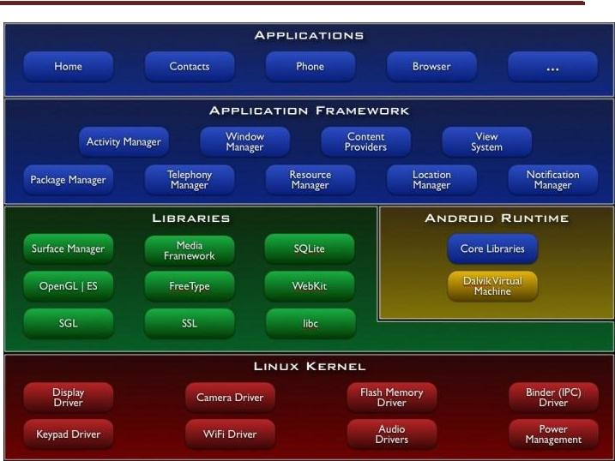

**2.7 Hardware And Software Requirements**

**2.7.1 Hardware Specification**

Processor -Pentium III or Higher

RAM - 2GB or Higher

Hard disk - 500 GB

**2.7.2 Software Specification**

Front end - HTML, JAVA Script

Back end - My SQL

Server Scripting Language - JAVA SERVER PAGES

Web Server - Glass Fish

Operating System - Windows 7 or Any Compatible

IDE - net beans 8.0

**CHAPTER 3**

**SYSTEM REQUIREMENT SPECIFICATION**

The project entitled “Project Tracking System” is an intranet web application product designed to manage the details of students’ academic projects carried out in our college

This project is mainly designed to manage the project details carried out by the students of various academic years.

Here the details of projects are presented according to the technology used, academic year and according guide also.

An easy to use interface has been developed using HTML and java script, the database has been managed using mysql, Apache web server has been used and server side scripting is done using PHP.

Here students could login to this application after having registered while registering they will be given a unique user name and password, they could search the projects according to technology used and academic years.

Guides could login with their username and password they could edit the details of projects which are being guided by them.

Admin has more privileges’ on data base.

**3.1 Users**

**3.2 Purpose**

This Project could be used to manage the details of projects done by the students in various academic years, the admin could generate the reports of project details according to year, guide etc which in turn helps the college staffs to guide the new students regarding project activity

**3.3 Scope**

Junior students of college could refer these projects and improve them by adding extra features to the existing projects, in existing system the details are managed manually which may cause the repetition of the projects the project guides could keep track of the projects guided by them, HOD of the department could trace the overall activity.

**3.4 Functional Requirements**

**Admin module**

In this project admin is the super user who has more privileges than other users, admin has rights to create staff’s, view all projects, search projects and generate project report of various departments

**Projects module**

In this module the details of the projects developed by the students are managed, guides are allowed to enter the details of projects being guided by them, the details of the projects could be edited by the guide.

**Guides module**

In this module the guides details are managed, each guide has an unique user name and password which is issued by the admin with which they could access the system, guides have rights to edit their profile and also edit the details of project being guided by them

**Search module**

In this module a provision is given to users of the system to search the projects details on various parameters like project title,technology used etc. search could be done in two ways first is general search where the users enters the search query generally according to their need, in custom search, search in done on specific conditions such as title, technology etc.

**Reports module**

In this module admin could generate the reports of projects according to department and year, report includes the details such as project title, technology used, project mates names. Admin could take the hard copy of the details generated for further purposes

**3.5 NON-FUNCTIONAL REQUIREMENTS**

**Correctness**

Since this project is used to provide the actual and correct information about details of the particular project which were done by students. The admin will have more privileges on the database, the system should always provide correct response and the data in all the database should always be constantly updated with the latest information.

**Reliability**

The system has to provide the correct information under any situation, In case of any error in input or output operation, system should reflect proper message or give proper helping information.

**Robustness**

It’s vital that the system should be a fault tolerant with respect to illegal user input. Error Checking must be built in the system to prevent system failure.

**Maintainability**

The project will be used for a long time, it must be easy to maintain and easy to incorporate future changes. The design if the system should be module based and changing the design of the one module should not affect the proper operation of the other module.

**Portability**

The system should be portable so as to can run in any web browser with very little or no modifications.

**4.1 SYSTEM PERSPECTIVE**

The main aim of the system perspective is to reduce the complexity of the system. Here the system is described as a whole not as an isolated individual system. Hence the relationship between the system and the environment is to be considered. This system perspective study also gives information regarding its behavior and properties, this may also include the interactions that the proposed system does with the present environment. This part of the report gives information about the system that is proposed and its relationship with the surrounding environment. The main components of this mobile application are as follows:

TABLES

TABLES

DATABASE SERVER

USERNAME AND PASSWORD AUTHENTICATION

ADMIN

STAFF

USERS

**4.2 CONTEXT DIAGRAM**

Projects

Searching

Students

Guides

**Figure 4.1: Context diagram of the proposed system**

**Description:** The diagram shows the functional units of the project, end users are app users who search for information , guides uploads all project related info.

**CHAPTER 5**

**DETAILED DESIGN**

* 1. **USECASE DIAGRAM**

Use case diagram it can be described as relationship of elements within a system

* + 1. **Use case diagram of Admin**

Admin

**Figure 5.1.1: Use case diagram for Admin**

Above diagram shows the privileges being given to user called admin, admin could manage all the information mentioned in the diagram.

* + 1. **Use case diagram of Guide**

Guide

**Figure 5.1.2: Use case diagram of Guide**

**5.2 Control flow diagram of guide**

Guide

Having an account ?

yes

No

Create account

Is user name and password are valid ?

No

yes

Allow to access the system

**5.3 DFD of Admin**

Admin

Guides Table

Notifications Table

Projects Table

**5.4 DFD of Guide**

Guide

Guides Table

Projects Table

**5.5 ER DIAGRAM**

N

1

1

1

Guides

Projects

Dept

Notifications

Belongs to

Has

Manages

Has

**5.6 Database design**

Following are the tables used in the project

**Department table**

|  |  |
| --- | --- |
| **Field** | **Type** |
| Deptid | Varchar(10) |
| Deptname | Varchar(100) |

**Table 5.6.1 Department table**

**Description:** This table is used to store the details of departments

**Guide table**

|  |  |
| --- | --- |
| **Field** | **Type** |
| Sino | int(11) |
| Name | Varchar(100) |
| Quali | Varchar(50) |
| Contno | Varchar(20) |
| Deptid | Varchar(10) |
| Uname | Varchar(20) |
| Pwd | Varchar(20) |
| Sque | Varchar(100) |
| Ans | Varchar(50) |
| Imgname | Varchar(100) |

**5.6.2 Department table**

**Description:** This table is used to store the details of guides.

**Project table**

|  |  |
| --- | --- |
| **Field** | **Type** |
| Pid | Varchar(20) |
| Title | Varchar(100) |
| Year | Int(11) |
| Deptid | Varchar(10) |
| Guide | Varchar(20) |
| Pmates | Varchar(100) |
| Tech | Varchar(100) |
| Descr | Text |
| Limits | Varchar(200) |
| Future | Text |

**5.6.3 Project table**

**Description**:This table is used to store the details of projects.

**Notification table**

|  |  |
| --- | --- |
| **Field** | **Type** |
| Sino | Int(11) |
| Deptid | Varchar(10) |
| Message | Varchar(500) |
| Ndate | Date |

**5.6.4 Project table**

**Description** This table is used to store the details of notifications.

**CHAPTER 6**

**IMPLEMENTATION**

Implementation is the stage of the project where the theoretical design is turned into a working system. It can be considered to be the most crucial stage in achieving a successful new system gaining the users confidence that the new system will work and will be effective and accurate. It is primarily concerned with user training and documentation. Conversion usually takes place about the same time the user is being trained or later. Implementation simply means conveying a new system design into operation, which is the process of converting a new revised system design into an operational one.

Implementation is the stage of the project where the theoretical design is tuned into a working system. At this stage the main work load, the greatest upheaval and the major impact on the existing system shifts to the user department. If the implementation is not carefully planned and controlled it can create chaos and confusion.

Implementation includes all those activities that take place to convert from the existing system to the new system. The new system may be a totally new, replacing an existing manual or automated system or it may be a modification to an existing system. Proper implementation is essential to provide a reliable system to meet organization requirements. The process of putting the developed system in actual use is called system implementation. This includes all those activities that take place to convert from the old system to the new system. The system can be implemented only after through testing is done and if it is found to be working according to the specifications. The system personel check the feasibility of the system. The more complex the system being implemented, the more involved will be the system analysis and design effort required to implement the three main aspects: education and training, system testing and changeover. The implementation state involves the following tasks:

• Careful planning.

• Investigation of system and constraints.

• Design of methods to achieve the changeover.

• Training of the staff in the changeover phase.

**6.1 Coding used in the project**

<%@ page language="java" %>

<%@ page import="java.sql.*" %>

<%

String driver = "com.mysql.jdbc.Driver";

String url = "jdbc:mysql://localhost/stuproj";

String username = "root";

String password = "";

Class.forName(driver);

Connection cn = DriverManager.getConnection(url, username, password);

PreparedStatement ps=null;

ResultSet rs=null;

%>

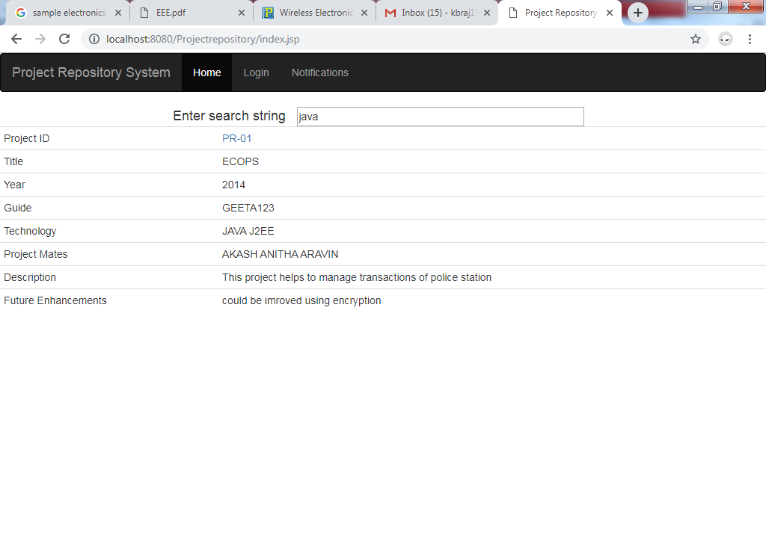**6.2 Screen shots**

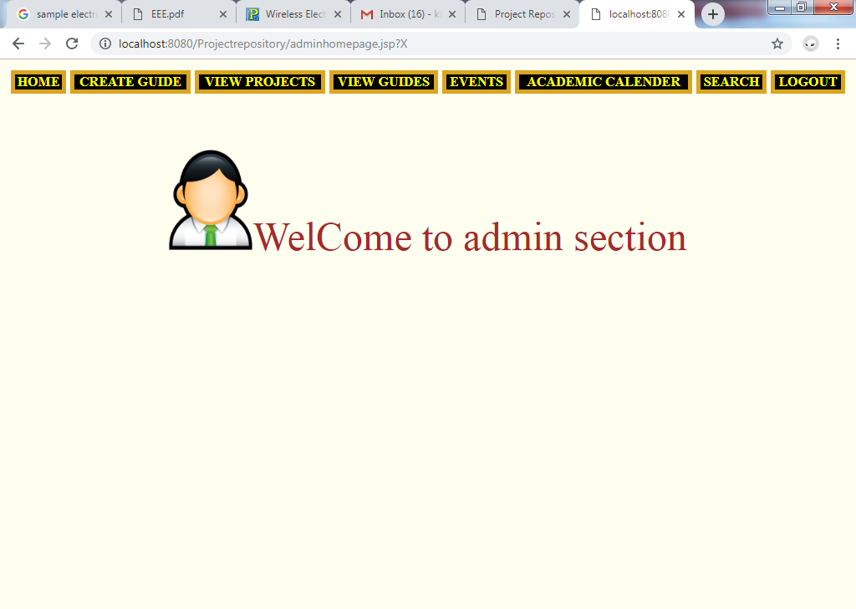

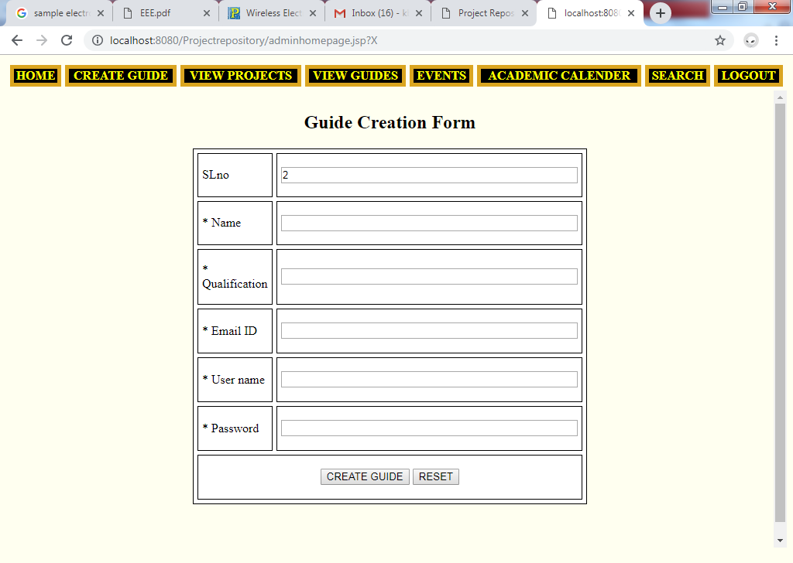

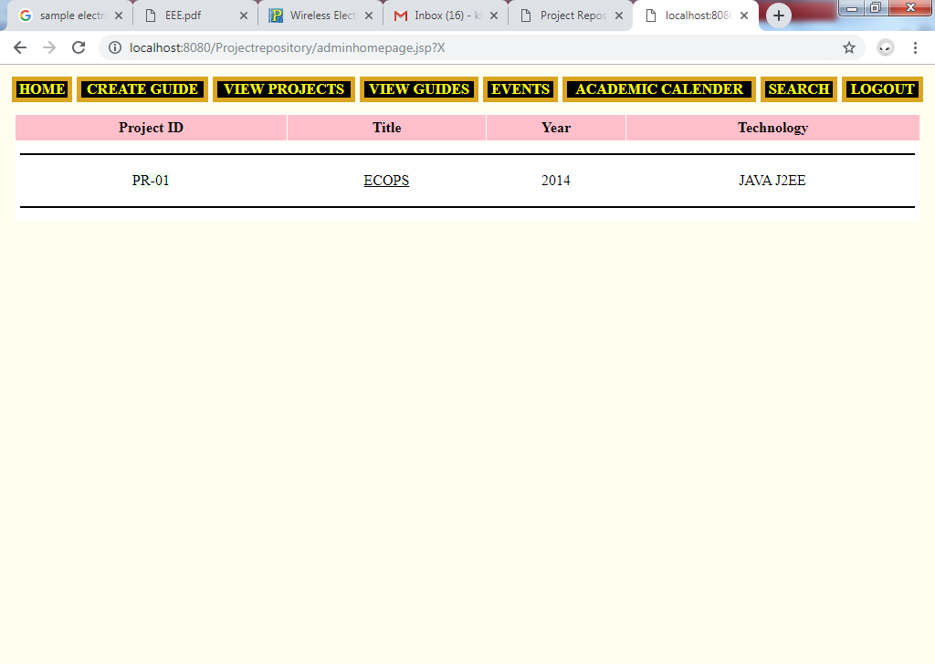

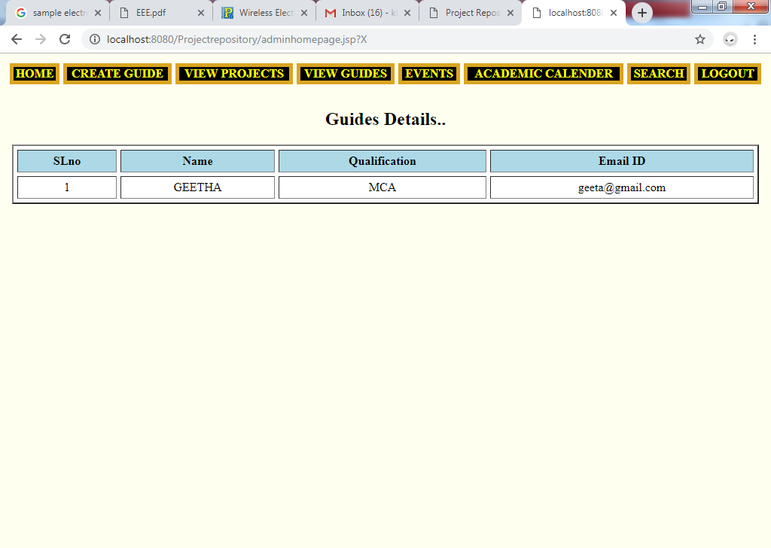

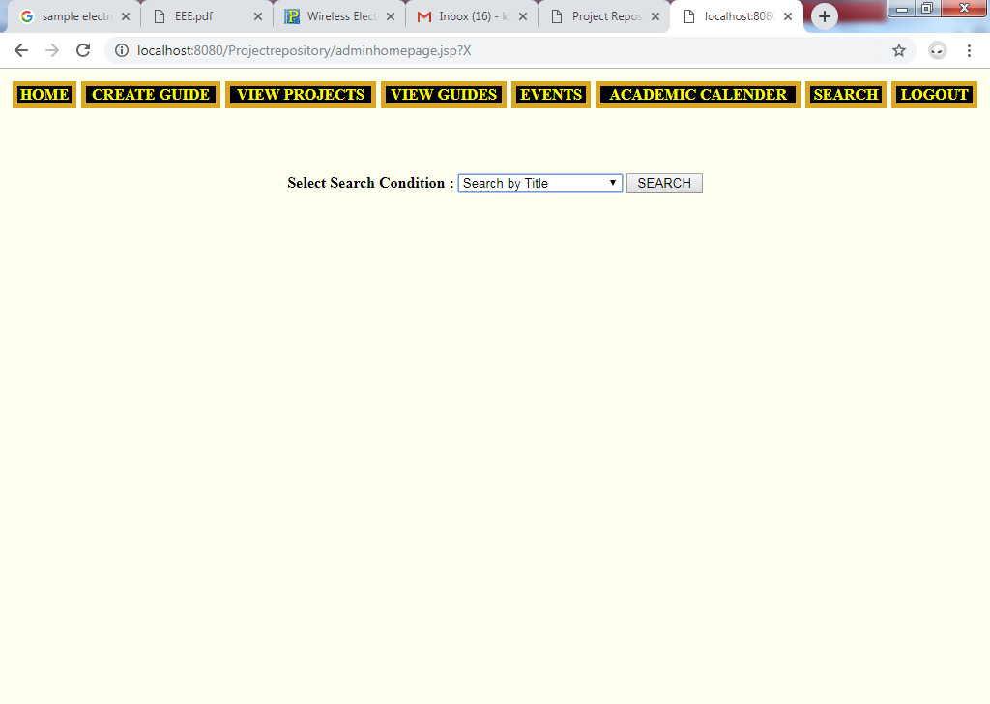

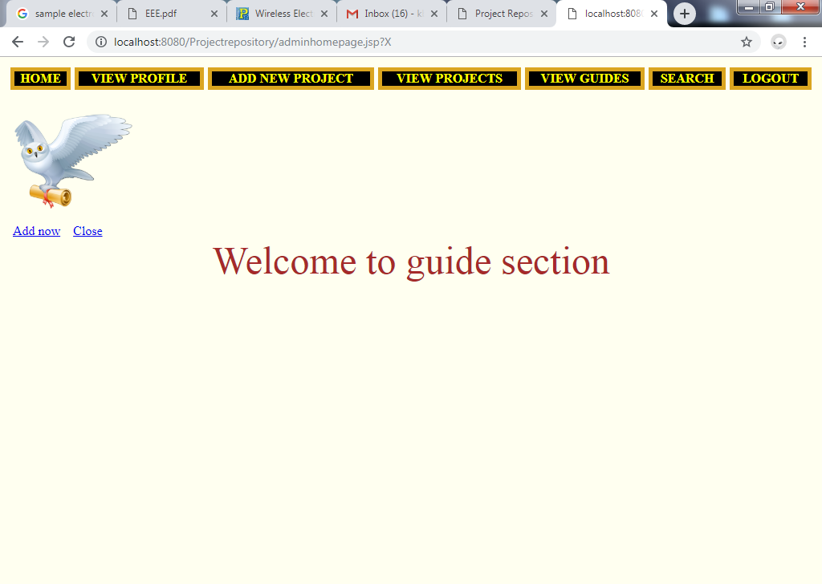

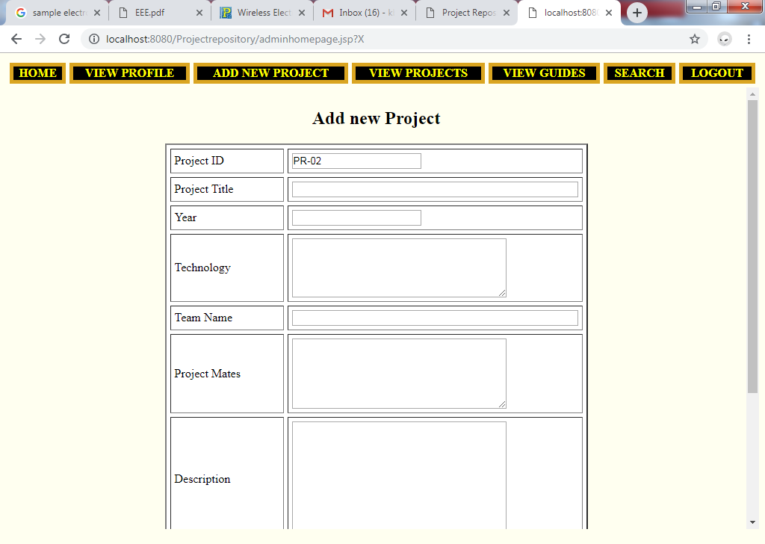

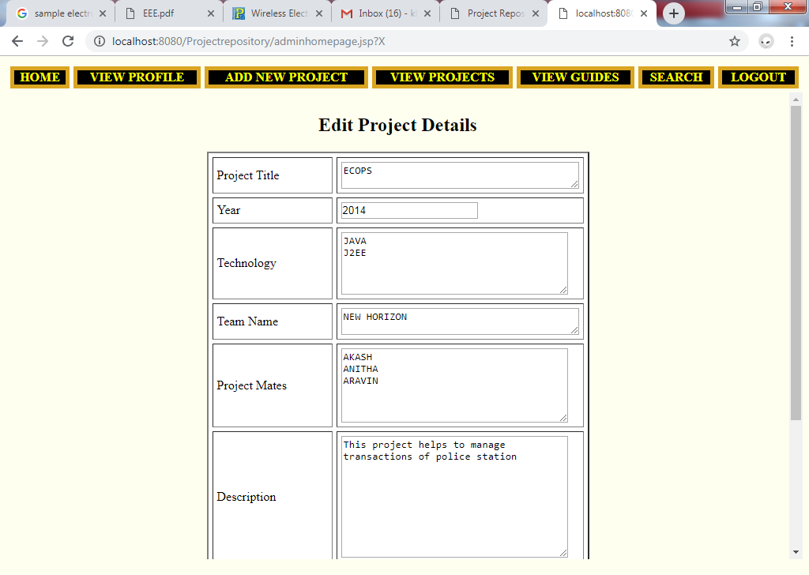

**CHAPTER 7**

**SOFTWARE TESTING**

Software testing is a critical element of the quality assurance and represents the specifications, design and coding. Testing aids to find anomaly of the software. During the development phase, it was attempted to build software from an abstract concepts to tangible implementations. The various types of tests done on the system are:

i. Unit testing

ii. Integrating testing

iii. System testing

**7.1 Unit Testing**

A unit testing focuses verification efforts on the smallest unit of the software design. Using unit testing plan prepared in the design phase of the system development as a guide, imported control paths are tested to uncover the errors within the modules.

In our system, if we consider the login page, if the user or administrator enters his details that are username and password, then the testing is done for validation so that he/she can enter into the particular module.

**7.2 Integration Testing**

Integration testing is the systematic technique for constructing the program structure while at the same time conducting the test to uncover the errors associated with the interface. The objective is to take unit tested modules and build the program structure that has been dictated by design. In our system both the user and admin module are combined in this testing step. Then the entire program is tested as a whole. All the errors which are found in the system were corrected for the next testing step.

**7.3 System Testing**

At the final point of testing, software is completely assembled as a package, interface errors have been uncovered and corrected and final series of system testing begins. System testing can be defined in many ways, but a simple definition is that the system succeeds when the software functions in a manner that can be reasonably black box tests that demonstrate conformity with requirements.

In our system the outputs generated are displayed by the system under consideration and are tested by comparing the format required by the user. Here the output format is considered in two ways, one is on the screen and other is in printed format.

**7.4. Test cases**

**Login**

|  |  |  |
| --- | --- | --- |
| **Input** | **Output** | **Conclusion** |
| 1. Login type: choose from the list 2. User name : user input 3. Password : user input | Either users are allowed to access the system or an error message is displayed. | User must have an account to access the system, giving a valid user name and password is must to access the system. |

**Add project**

|  |  |  |
| --- | --- | --- |
| **Input** | **Output** | **conclusion** |
| 1. Project id: auto generated 2. Title : user input 3. Year : user input 4. Project mates: user input 5. Department id: user input 6. Guide: user input 7. Technologies Used: user input 8. Description: user input 9. Limitations: user input 10. Future enhancement: user input | Record is saved to data base | Record will be saved if all mandatory fields are filled otherwise an alert message will be displayed |

**Add guides**

|  |  |  |
| --- | --- | --- |
| **Input** | **Output** | **conclusion** |
| 1. Serial number: auto generated 2. Name : user input 3. Qualification : user input 4. Contact number: user input 5. Department id: Select from the list 6. User name: user input 7. Password: user input 8. Security Question : user input 9. Answer: user input 10. Image Name: select image | Record is saved to data base | Record will be saved if all mandatory fields are filled otherwise an alert message will be displayed |

**CHAPTER 8**

**CONCLUSION**

Using our project the following tasks could be done easily. Store the details of projects being developed. Manage the details of guides. Search the projects according to various conditions. Proper guidelines could for developing projects, preparing synopsis and reports could be obtained.

This project is an attempt made by us to full fill the above said requirements proper planning, testing and execution is made but it could be improved further by adding more features to it, we have enjoyed the course of project development work.

**CHAPTER 9**

**FUTURE ENCHANCEMENTS**

* Using suitable algorithm projects should be assigned to guides according to the platform on which project being developed
* Important code snippet should be made available
* Discussion forum could be made to discuss and clear the doubts.

**APPENDIX A**

**BIBILOGRAPHY**

**BOOKS**

1. Java 2 : The Complete Reference.

By Patrick Naughton and Herbert Schildt.

1. Java 6 : By Sams Teach Yourself
2. Database System Concepts : by Korth and Sudarshan
3. Web Technology & Design : By C.Xavier

**SITE**

* [www.w3schools.com/](http://www.w3schools.com/)
* [www.sitepoint.com/article/](http://www.sitepoint.com/article/)
* [www.google.com/](http://www.google.com/)

**Appendix B**

**USER MANUAL**

**For students**

**Step 1:**

Open the website with its URL, on right side of the home page there is a search box, input the parameters such as project name, title or year etc. get the result displayed instantly.

**Step2:**

On left sidebar there are links to view notifications, get synopsis and report templates, click on them to get work done.

**For Guides**

**Step1:**

Get the account created by the admin; admin will issue user name and password

**Step2:**

Launch web application with URL,on the homepage there is a link called login using that link login with user name and password given by the admin

**Step3:**

After successful login you will be redirected to homepage, it is associated with various links and dropdown menu, using those links manage projects, profile etc.